# STUDENT CARD APPLICATIONS

**1 Photo upload**

Students can upload their photograph to apply for a student card using the link below as soon as we have received and processed their enrolments. They will need to know their SRN (Student Registration Number) and the date of birth must be correct on UNITe. Most crucially, students must have a live enrolment for this to work.

The Card Office produce cards and send them to the Data Team for posting to the relevant HE Admin Office or named person.

Process as follows:-

1. Go to <https://eservices.plymouth.ac.uk/app/> Add student reference number (SRN), date of birth, surname/family name and then click ‘Login’.

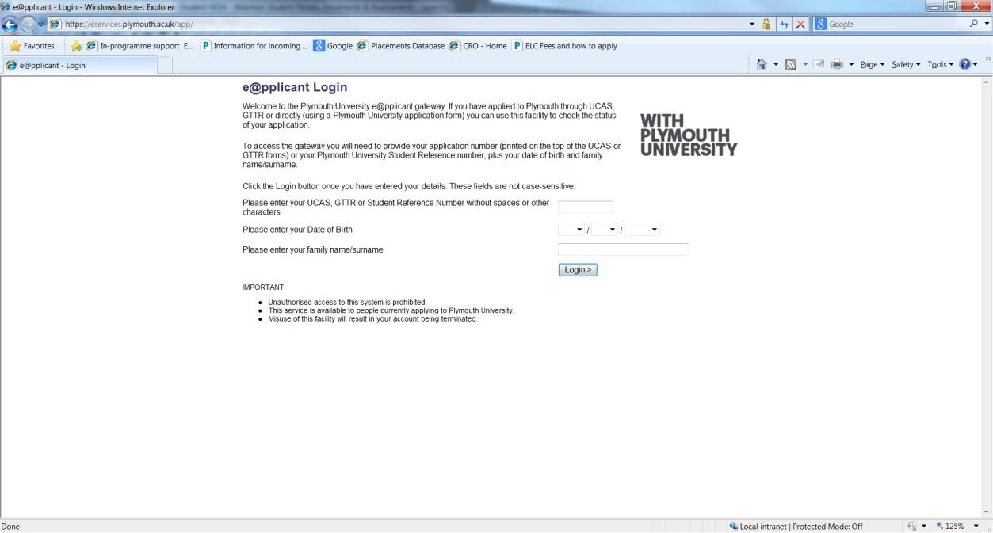

2 Click ‘Upload a photo for your University Card’

3. Read the instructions carefully; click ‘browse’ to select a photograph and then ‘upload file’. If the picture is too large, instructions will be given on how to crop it.

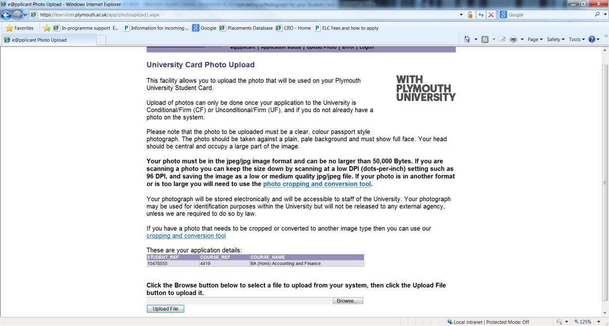

4. An image of the student card will be shown – click ‘yes’ to confirm.